PROJECT BLUEPRINT
Material & Subcontractor Cost Variance Pipeline (The ETL & Blending Play)
The Business Problem: Construction projects notoriously bleed money when material costs fluctuate from the original quote, or when subcontractors overbill for hours.The Data Generation: Use Python to script out three distinct datasets:
Vendor_Quotes: Original estimated costs for lumber, concrete, electrical, etc.
Subcontractor_Invoices: Messy, unstructured invoice data with varying formats and timestamps.
Project_Milestones: Dates when specific phases of a job were actually completed.The Technical Execution: Build an Alteryx workflow to blend these three disparate data sources into a single "Single Source of Truth" master dataset. You can highlight how you replaced a highly manual reconciliation process by creating a clean pipeline that flags budget overruns in real-time.

1. The Data Schemas (The Blueprint)
To make this look like a real business problem, we need a common key to link the tables (e.g., Project_ID), but we intentionally want the data to be a bit messy to justify your data cleansing work.
Table 1: Vendor_Quotes (The Baseline) This represents the original estimated costs for the jobs.
- Quote_ID (Primary Key)
- Project_ID (Foreign Key)
- Trade_Type (e.g., Electrical, Plumbing, Framing, Concrete)
- Estimated_Material_Cost
- Estimated_Labor_Hours
- Quote_Date
Table 2: Subcontractor_Invoices (The Messy Reality) This is the operational data where cost overruns happen. We will inject realistic dirty data here (nulls, inconsistent date formats, duplicate submissions).
- Invoice_ID (Primary Key)
- Project_ID (Foreign Key)
- Subcontractor_Name
- Billed_Material_Cost
- Billed_Labor_Hours
- Invoice_Date (Intentionally messy formats like MM/DD/YYYY, YYYY-MM-DD, etc.)
- Status (Paid, Pending, Disputed)
Table 3: Project_Milestones (The Timeline) This tracks the actual progress to see if time delays correlate with cost overruns.
- Milestone_ID (Primary Key)
- Project_ID (Foreign Key)
- Phase_Name (e.g., Foundation, Rough-in, Drywall)
- Target_Completion_Date
- Actual_Completion_Date
- Delay_Reason (Weather, Supply Chain, Labor Shortage - some nulls)

2. The Python Data Generation Strategy
We will use Python with the pandas and Faker libraries to instantly generate thousands of rows of realistic data for these three tables.
By setting a random seed, we can ensure that the Project_IDs match up across all three generated CSV files, allowing you to join them later. We will programmatically force about 15-20% of the projects to go over budget so you have a solid "business problem" to uncover in your dashboard.

3. The ETL Execution (What goes on the resume)
Once we generate the CSVs, your narrative for the resume (and the interview) will be how you built the Alteryx workflow (or SQL pipeline) to handle it:
- Data Cleansing: Standardizing the messy Invoice_Date strings into unified Date/Time data types and handling nulls in the Delay_Reason column.
- Data Blending: Using Joins/Unions to blend the Subcontractor_Invoices against the baseline Vendor_Quotes on Project_ID and Trade_Type.
- Transformations: Creating new calculated columns, such as Cost_Variance_Amount and Labor_Overage_Percentage.
- The Output: Outputting a clean, structured master dataset into Tableau to build the final Variance Dashboard.

AI Figma Prompt: "Construction Cost Variance & Subcontractor Performance Dashboard"
Target Audience: Construction Executives and Project Managers. Goal: To quickly identify which projects are bleeding money, which trades/subcontractors are overbilling, and how project delays correlate with budget overruns. Vibe & Theme: Professional, clean, and modern. Dark mode or a crisp light mode with high-contrast accent colors for variances (e.g., Red for over budget, Green for under budget).
1. Global Navigation & Filters (Left Sidebar or Top Bar)
- Filters: Dropdowns for Date Range, Project ID, Trade Type (Electrical, Framing, Concrete, etc.), and Project Status (Active, Completed).
- Layout: Needs to be scannable, leaving the main canvas for the data.
2. The KPI Ribbon (Top Row - High-Level Metrics) This section should feature four distinct "Cards" highlighting the most critical numbers:
- Total Cost Variance ($): Total Actual Cost minus Total Estimated Cost. (Color-coded red if actual is higher).
- Overall Budget Health (%): Percentage of total budget consumed vs. project completion percentage.
- Labor Overrun Hours: Total billed hours minus quoted hours.
- Delayed Milestones: A count of project phases that missed their target completion date.
3. Main Visualizations (Middle Section - The "Why") This area should be split into two or three main charts to show trends and drivers:
- Budget vs. Actual by Trade (Bullet Chart or Bar Chart): A side-by-side comparison showing the original quote vs. the actual billed amount, broken down by Trade Type (e.g., Plumbing, Drywall). This shows where the money is going.
- Cost Variance Over Time (Line Chart with Dual Axis): A timeline showing cumulative project spend against the baseline budget curve. Spikes in this line indicate sudden subcontractor overbilling.
- Delay vs. Cost Correlation (Scatter Plot): X-axis is Days Delayed, Y-axis is Cost Variance ($). Each dot is a project phase. This visually answers: "Do weather delays cause budget blowouts?"
4. Granular Detail / Drill-Down (Bottom Section - The Actionable Data)
- Subcontractor Audit Table: A clean, sortable data table detailing the worst offenders.
- Columns: Subcontractor Name, Project ID, Invoice Count, Quoted Amount, Billed Amount, Variance ($), Variance (%).
- UX Feature: Include a visual sparkline or a red/green status indicator in the table for quick scanning.

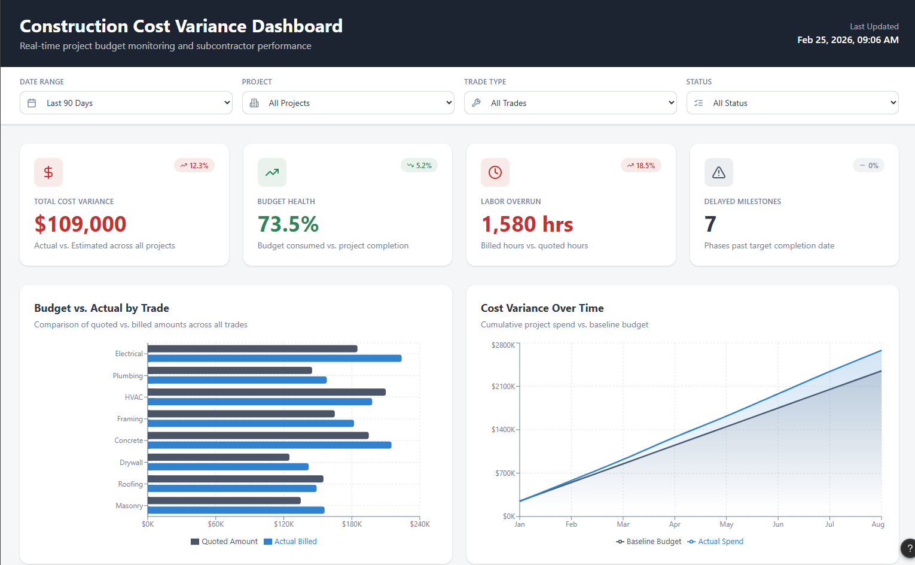
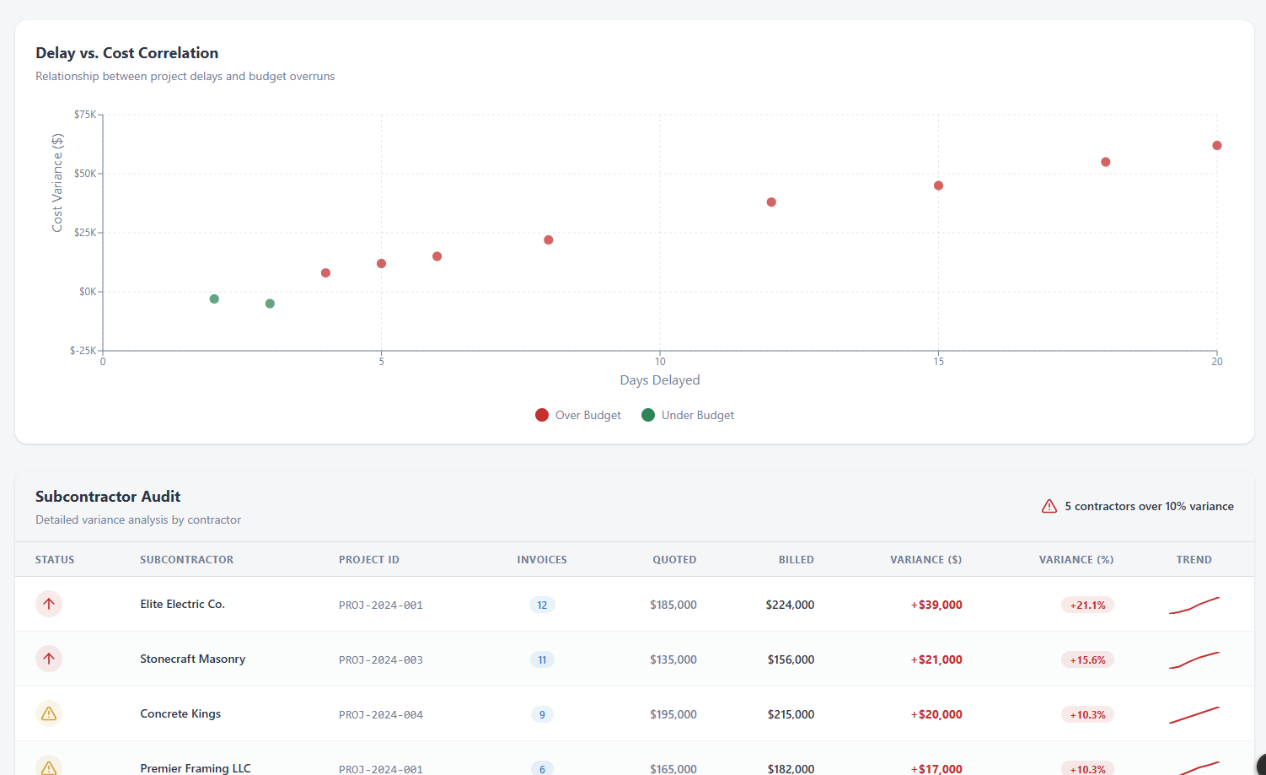

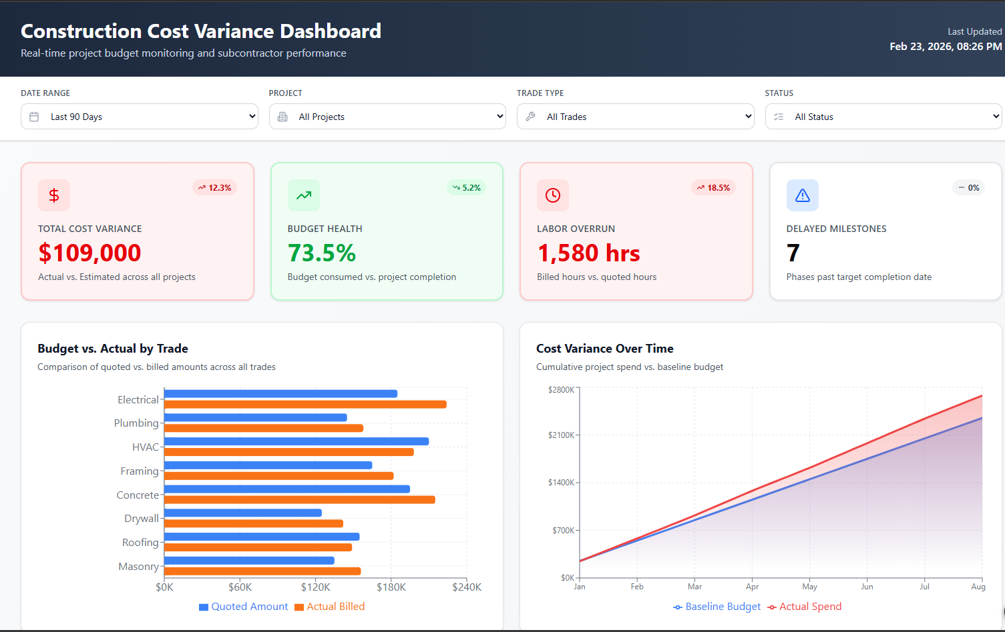
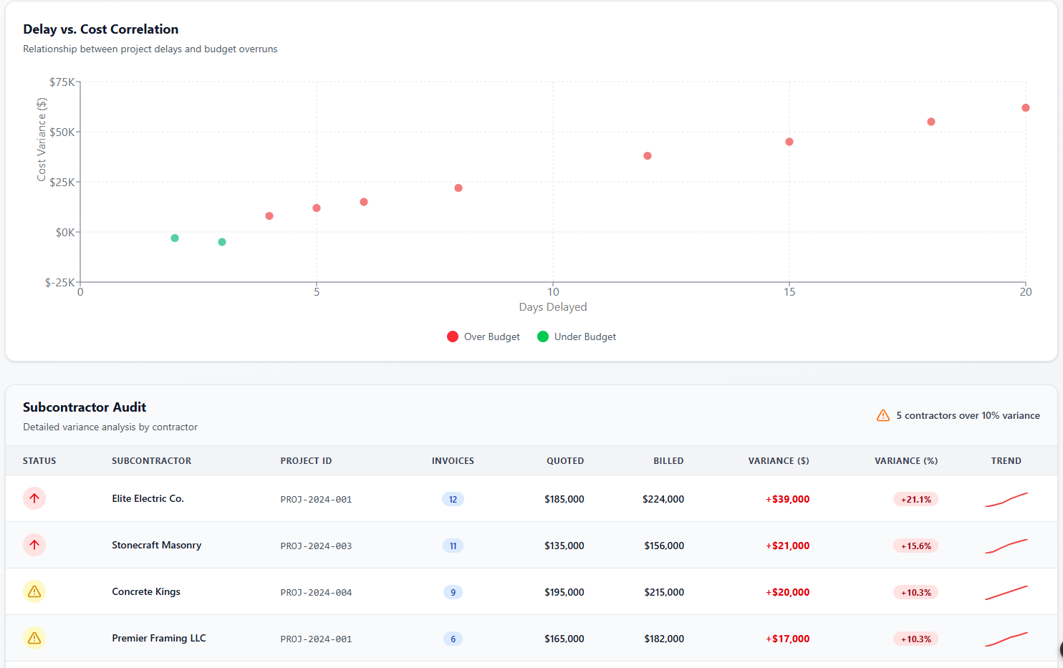

Phase 1: Data Ingestion & Type Casting
- Input Data (x3): Drag three Input Data tools onto your canvas and connect them to your generated Vendor_Quotes.csv, Subcontractor_Invoices.csv, and Project_Milestones.csv.
- Select (x3): Attach a Select tool immediately after each input.
  - Why: CSVs default to string data types. You must manually cast Quoted_Amount, Billed_Amount, etc., to Double or Fixed Decimal. Change the ID columns to String so they don't accidentally get aggregated later.
Phase 2: The Data Cleansing Stream (The "Messy" Invoices)
This is where you earn your money. We programmed the Subcontractor_Invoices to be dirty, so we need a dedicated stream to clean it up before joining.
- Data Cleansing: Connect this to the Invoice Select tool. Configure it to replace Null values in the Invoice_Date string column with a default placeholder (e.g., '1900-01-01') or leave them blank, and strip any leading/trailing whitespace from the Subcontractor_Name.
- DateTime: Since we injected mixed date formats (MM/DD/YYYY and YYYY-MM-DD), use the DateTime tool to parse the Invoice_Date string into a standard Alteryx Date format. Note: You might need a Formula tool with an IF/THEN statement if the standard DateTime tool trips up on the heavy mixing.
- Filter: Add a Filter tool with the logic [Status] != "Disputed".
  - The Business Story: "I built the pipeline to exclude disputed invoices from the actual spend calculation so we don't prematurely flag a project as over-budget."
- Summarize: Because one quote can have multiple invoices, you must roll them up before the join, or you will duplicate your baseline data. Group By Project_ID, Subcontractor_Name, and Trade_Type. Sum Billed_Amount (rename to Total_Billed_Amount) and Sum Billed_Hours (rename to Total_Billed_Hours).
Phase 3: The Master Blending (Joins)
Now we bring the three streams together.
- Join 1 (Quotes + Clean Invoices): Connect the Vendor_Quotes stream (L) and your Summarized Invoices stream (R). Join on both Project_ID and Trade_Type.
  - Pro-tip: Pay attention to the J (Inner Join), L (Unbilled quotes), and R (Orphaned invoices) outputs. For the master dataset, take the J output, but in an interview, mention that you would output the R anchor to a separate "Data Quality Exception" report.
- Join 2 (Master + Milestones): Connect the J output of Join 1 (L) and the Project_Milestones stream (R). Join on Project_ID and Trade_Type to bring in the Days_Delayed metric.
Phase 4: Business Logic & Metrics (The Secret Sauce)
Attach a Formula tool to the J output of Join 2. This is where you pre-calculate the metrics Tableau needs so the dashboard renders instantly. Create these new columns:
- Cost_Variance_Amount = [Total_Billed_Amount] - [Quoted_Amount]
- Cost_Variance_Percent = ([Total_Billed_Amount] - [Quoted_Amount]) / [Quoted_Amount]
- Labor_Variance_Hours = [Total_Billed_Hours] - [Quoted_Hours]
- Is_Over_Budget_Flag = IF [Cost_Variance_Amount] > 0 THEN 1 ELSE 0 END (This makes counting delayed/over-budget projects incredibly easy in Tableau).
Phase 5: Output
- Select: Add one final Select tool to drop redundant Right_Project_ID columns and reorder your fields so they are logical (IDs first, dimensions second, metrics last).
- Output Data: Write this out to a Master_Construction_Variance.csv (or directly to a Tableau .hyper extract file if you have the driver installed).

